**STAGE 3**

**Report**

**SOC**

SOC stands for Security Operations Center. It is a centralized facility or team responsible for monitoring an organization's security, detecting and responding to cybersecurity incidents, and protecting against threats to the organization's information systems and data.

Primary functions of SOC include:

* Monitoring: The SOC continuously monitors network traffic, system logs, and security events to identify abnormal or suspicious activities. This monitoring can be done in real-time or through retrospective analysis.
* Incident Detection: SOC analysts use various tools and technologies to detect security incidents, including unauthorized access, malware infections, data breaches, and other cyber threats. They look for patterns and anomalies in the data that could indicate an attack.
* Incident Response: When a security incident is detected, the SOC team responds by investigating the incident, containing the threat, and mitigating the impact. This may involve isolating affected systems, removing malware, and patching vulnerabilities.
* Threat Intelligence: SOC teams often rely on threat intelligence feeds and databases to stay informed about the latest cyber threats and vulnerabilities. This information helps them proactively defend against known threats.
* Security event analysis: SOC analysts analyze security events to determine their severity and impact on the organization. They prioritize incidents based on their potential harm and take appropriate action accordingly.
* Security alerts: When a security incident is confirmed, the SOC team generates security alerts and notifies the relevant stakeholders, including IT personnel, management, and, in some cases, external authorities and incident response teams.
* Forensics and Investigation: In the event of a security breach, the SOC conducts detailed forensic analysis to understand how the breach occurred, what data may have been compromised, and how to prevent future incidents.
* Vulnerability management: The SOC may be responsible for managing vulnerability assessments and helping to remediate security weaknesses in the organization's infrastructure and applications.
* Threat hunting: Proactive threat hunting is the practice of actively searching for signs of potential threats or vulnerabilities in an organization's environment, even before they trigger security alerts.
* Security Training and awareness: The SOC often plays a role in educating employees about security best practices and helping to raise awareness of potential threats through security awareness programs.

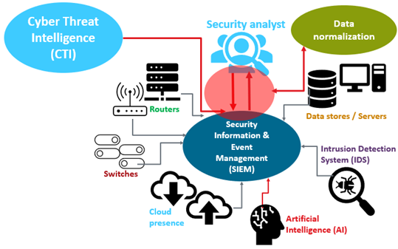

**SOC Cycle**

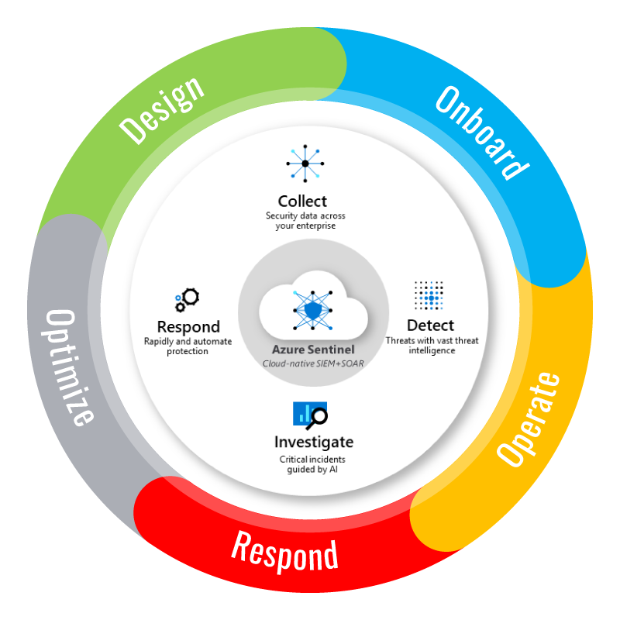

**SIEM**

Security information and event management, or SIEM, is a security solution that helps organizations recognize and address potential security threats and vulnerabilities before they have a chance to disrupt business operations. SIEM systems help enterprise security teams detect user behavior anomalies and use artificial intelligence (AI) to automate many of the manual processes associated with threat detection and incident response.

How does SIEM work?

* **Log Management**

SIEM ingests event data from a wide range of sources across an organization’s entire IT infrastructure, including on-premises and cloud environments. Event log data from users, endpoints, applications, data sources, cloud workloads, and networks—as well data from security hardware and software such as firewalls or antivirus software—is collected, correlated and analyzed in real-time.

* **Event Correlation and Analytics**

Utilizing advanced analytics to identify and understand intricate data patterns, event correlation provides insights to quickly locate and mitigate potential threats to business security. SIEM solutions significantly improve mean time to detect (MTTD) and mean time to respond (MTTR) for IT security teams by offloading the manual workflows associated with the in-depth analysis of security events.

* **Incident Monitoring and Security Alerts**

SIEM consolidates its analysis into a single, central dashboard where security teams monitor activity, triage alerts, identify threats and initiate response or remediation. Most SIEM dashboards also include real-time data visualizations that help security analysts spot spikes or trends in suspicious activity. Using customizable, predefined correlation rules, administrators can be alerted immediately and take appropriate actions to mitigate threats before they materialize into more significant security issues.

* **Compliance Management and Reporting**

SIEM solutions are a popular choice for organizations subject to different forms of regulatory compliance. Due to the automated data collection and analysis that it provides, SIEM is a valuable tool for gathering and verifying compliance data across the entire business infrastructure.

Ultimately, a SIEM solution offers a centralized view with additional insights, combining context information about your users, assets and more. It consolidates and analyzes the data for deviations against behavioral rules defined by your organization to identify potential threats. Data sources can include:

* Network devices: Routers, switches, bridges, wireless access points, modems, line drivers, hubs
* Servers: Web, proxy, mail, FTP
* Security devices: Intrusion prevention systems (IPS), firewalls, antivirus software, content filter devices, intrusion detection systems (IDS) and more
* Applications: Any software used on any of the above devices
* Cloud and SaaS solutions: Software and services not hosted on-premises

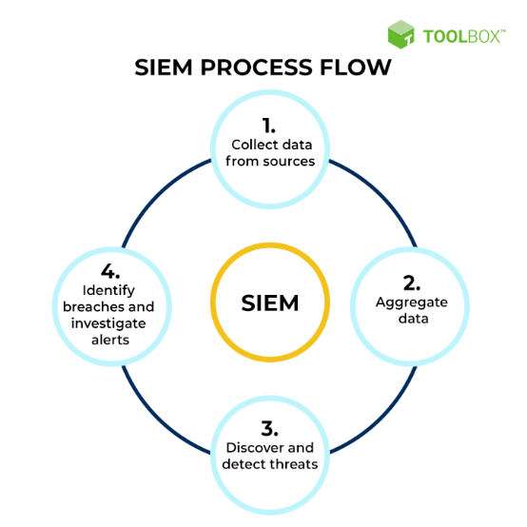

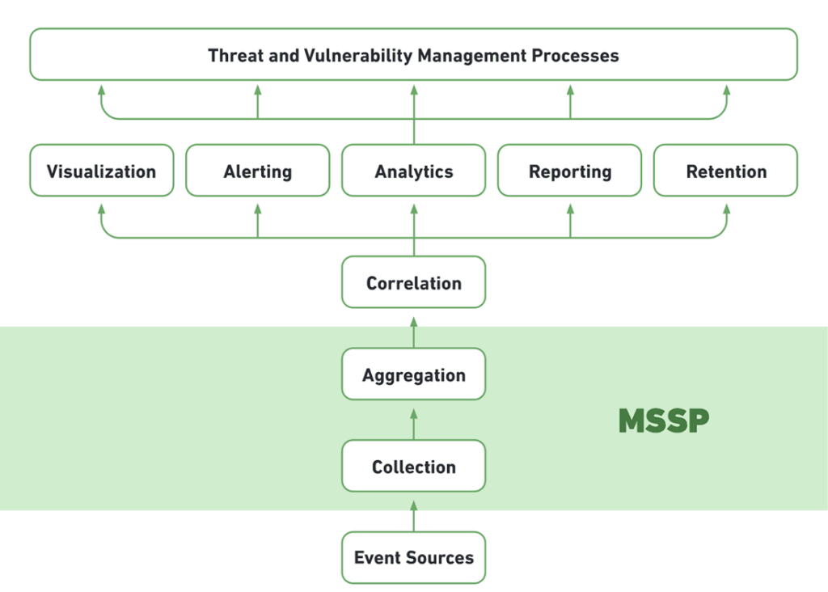

**MISP**

**Malware Information Sharing Platform**

MISP - Open Source Threat Intelligence and Sharing Platform allows organizations to share information such as threat intelligence, indicators, threat actor information or any kind of threat which can structured in MISP. MISP users benefit from the collaborative knowledge about existing malware or threats. The aim of this trusted platform is to help improving the counter-measures used against targeted attacks and set-up preventive actions and detection.

Features:

* An efficient IoC and indicators database allowing to store technical and non-technical information about malware samples, incidents, attackers, and intelligence.
* A flexible data model where complex objects can be expressed and linked together to express threat intelligence, incidents or connected elements.
* Built-in sharing functionality to ease data sharing using different model of distributions. MISP can automatically synchronize events and attributes among different MISP. Advanced filtering functionalities can be used to meet each organization sharing policy including a flexible sharing group capacity and an attribute level distribution mechanism.
* An intuitive user-interface for end-users to create, update and collaborate on events and attributes/indicators. A graphical interface to navigate seamlessly between events and their correlations. An event graph functionality to create and view relationships between objects and attributes.
* data-sharing: automatically exchange and synchronization with other parties and trust-groups using MISP.
* Flexible API to integrate MISP with your own solutions. MISP is bundled with PyMISP which is a flexible Python Library to fetch, add or update events attributes, handle malware samples or search for attributes.

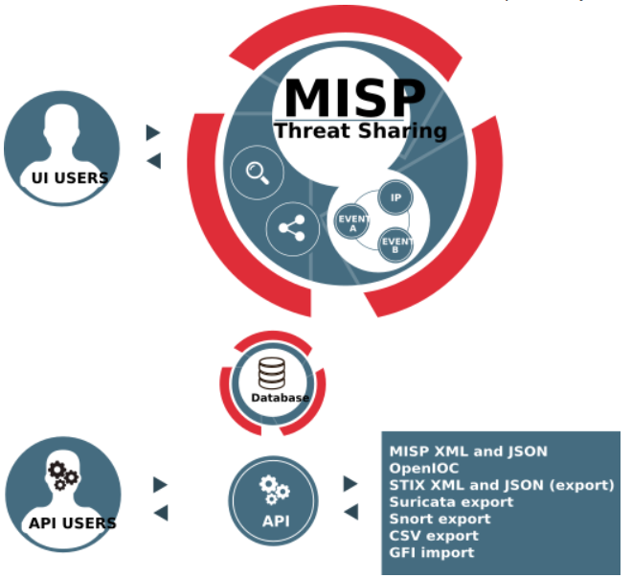

**MSSP**

A managed security service provider (MSSP) is an information technology (IT) service provider that sells security services to businesses. The role of an MSSP is to help protect businesses from security threats, whether that means providing software and services that keep company data safe or building a network of security experts who can respond to attacks as they happen.

**What is MSSP used for?**

An MSSP should provide a complete outsourced security solution for an organization. The core of the MSSP business is providing security monitoring and incident response for an organization’s enterprise networks and endpoints. However, as enterprise networks grow and evolve, support for other platforms, such as cloud-based infrastructure, has become a common component of MSSPs’ security portfolio.

**Benefits of an MSSP**

An MSSP is intended to augment or replace an organization’s internal security team. By partnering with an MSSP, a company can reap several benefits:

* **Filling Vacant Roles**: The cybersecurity skills gap means that filling vacant positions on an organization’s internal security team can be difficult and expensive. Partnering with an MSSP enables an organization to fill gaps within its internal security team or to replace it entirely.
* **Access to Specialist Expertise**: Limited cybersecurity headcount isn’t the only impact of the cybersecurity skills gap. Organizations also periodically require access to specialized cybersecurity expertise (such as malware analysts or forensics specialists) if an incident has occurred. An MSSP has the scale required to retain this expertise in-house and makes it available to customers as needed.
* **Round-the-Clock Protection**: Cyberattacks can occur at any time, not just during an organization’s standard business hours. An MSSP should provide a 24/7 SOC, providing continual detection and response to potential cyberattacks.
* **Increased Security Maturity**: Many organizations, especially small and medium-sized businesses, do not have the level of cybersecurity maturity that they require. With an MSSP, SMBs can rapidly deploy a mature cybersecurity solution.
* **Solution Configuration and Management**: Cybersecurity solutions are most effective when they are configured and managed by an expert. When partnering with an MSSP, an organization gains the benefit of expert security management without paying to have the required talent in-house.
* **Lower Total Cost of Ownership**: Many cybersecurity solutions offer support for multi-tenancy and high scalability. This enables an MSSP to use the same solution to support multiple clients, spreading the cost of a robust cybersecurity infrastructure across their client base.
* **Compliance Support**: The regulatory landscape is growing more complex as new data protection regulations (such as the GDPR and the CCPA) join existing laws (like HIPAA and PCI DSS). An MSSP can help with collecting data and generating reports for demonstrating compliance during audits or after a potential incident.

**College Network Information:**

**Implementing SOC in Campus**

Colleges and universities require a large and diverse network to provide easy access to students, faculty, and office staff. These types of open

SOC teams use a variety of technologies, software, and processes to spot system vulnerabilities and avoid attacks. Some of the most common tools used by a SOC team include firewalls, probes, security information and event management (SIEM) services, and data logs. Here, we can implement IBM QRadar as the SIEM.

**Steps to Building a SOC:**

* Organizational Buy-in
* Form an SOC leadership team.
* Define audit scope.
* Write policies and procedures.
* Implement technical configuration and controls.
* Conduct a readiness assessment.

**Threat Intelligence:**

Threat intelligence is a critical component of modern cybersecurity, providing organizations with the knowledge and insights needed to defend against cyber threats effectively. It encompasses the collection, analysis, and dissemination of information about potential and existing cyber threats, including malware, vulnerabilities, and the tactics, techniques, and procedures (TTPs) used by threat actors. Threat intelligence helps organizations stay one step ahead of cybercriminals, enhance their security posture, and proactively respond to security incidents.

There are various sources of threat intelligence, including open-source feeds, commercial services, and government agencies. These sources provide data about known threats, vulnerabilities, and indicators of compromise (IoCs). Security teams use this information to understand the threat landscape and make informed decisions about security measures and incident response.

Threat intelligence can be categorized into three main types:

1. **Strategic Threat Intelligence:** This provides a high-level view of long-term trends and risks, helping organizations make informed decisions about their overall security strategy and investments.
2. **Operational Threat Intelligence:** This type focuses on the immediate threats that an organization may face, such as known vulnerabilities or malware campaigns. It aids in day-to-day decision-making, like patch management or adjusting security policies.
3. **Tactical Threat Intelligence:** Tactical intelligence offers specific details about threats, including detailed IoCs, tactics, and threat actor profiles. This is invaluable for incident response and threat detection.

Threat intelligence is invaluable for enhancing an organization's security posture. By understanding the threat landscape, organizations can take proactive measures to protect their systems and data, including implementing security controls, patching vulnerabilities, and configuring security tools to detect and block known threats. It also plays a vital role in incident response, as it enables security teams to recognize and mitigate security incidents swiftly.

**Incident Response:**

Incident response is a structured approach to addressing and managing security incidents effectively. Security incidents can range from a wide array of events, including data breaches, malware infections, insider threats, and denial-of-service attacks. An incident response plan provides organizations with the procedures and tools necessary to identify, contain, eradicate, and recover from these incidents. A well-defined incident response process is essential to minimize the impact of a security breach and reduce recovery time and costs.

Key components of an incident response plan include:

1. **Preparation:** This stage involves creating and maintaining an incident response plan, assembling an incident response team, and ensuring that the necessary tools and resources are available.
2. **Identification:** During this phase, security incidents are detected and confirmed. This may involve monitoring alerts, analyzing logs, and conducting forensics to understand the nature and scope of the incident.
3. **Containment:** Once an incident is confirmed, immediate actions are taken to prevent it from spreading further and causing additional damage.
4. **Eradication:** Security teams work to eliminate the root cause of the incident, ensuring that the threat is completely removed from the affected systems.
5. **Recovery:** After the threat is eradicated, the organization can start the process of restoring normal operations. This may involve restoring data from backups, patching vulnerabilities, and strengthening security measures.
6. **Lessons Learned:** After an incident is resolved, it's crucial to conduct a post-incident analysis to identify weaknesses in the response process and make improvements for the future.

Incident response is not only about dealing with the aftermath of a security incident but also about being well-prepared in advance. Proactive measures, such as creating an incident response plan, training staff, and implementing security controls, are vital to effective incident response.

**Qradar and Understanding About the Tool:**

IBM QRadar is a powerful Security Information and Event Management (SIEM) solution designed to help organizations collect, analyze, and respond to security events and incidents in real-time. It provides a comprehensive view of an organization's security landscape, combining data from various sources, such as logs, network traffic, and vulnerability data, to detect and respond to threats efficiently.

Key features and capabilities of IBM QRadar include:

1. **Log and Event Management:** QRadar collects and normalizes data from numerous sources, making it easier to analyze and correlate events across the network. It supports a wide range of log sources, including network devices, security appliances, and operating systems.
2. **Real-time Monitoring:** QRadar offers real-time monitoring and alerting, enabling security teams to quickly detect and respond to suspicious activities and security incidents.
3. **Behavior Analytics:** The tool uses advanced analytics to detect anomalous behavior patterns, allowing organizations to identify threats even when there are no known signatures.
4. **Incident Management:** QRadar provides workflows for incident investigation and management. It helps security teams coordinate and document their response efforts.
5. **Threat Intelligence Integration:** QRadar can ingest threat intelligence feeds and indicators of compromise (IoCs), helping organizations stay updated on the latest threats and vulnerabilities.
6. **User and Entity Behavior Analytics (UEBA):** QRadar includes UEBA functionality to monitor the behavior of users and entities within the organization, helping to detect insider threats and abnormal activities.
7. **Forensics and Data Retention:** The tool offers capabilities for forensic analysis and long-term data retention, allowing organizations to investigate historical data when needed.
8. **Compliance and Reporting:** QRadar helps organizations meet regulatory compliance requirements by providing pre-built reports and dashboards for various compliance standards.

**Conclusion:**

**Stage 1: Web Application Testing:**

Web application testing is a critical process in the field of software quality assurance. It involves systematically assessing web-based applications to ensure they function correctly and securely. The primary goal is to identify vulnerabilities, bugs, and usability issues that may affect the user experience or expose the application to security threats. During this stage, the testing team conducts various types of assessments, including functional testing, security testing, performance testing, and usability testing. The results help developers and stakeholders make necessary improvements to the application. In conclusion, web application testing is essential for delivering a reliable and secure online experience for users.

**Stage 2: The Nessus Report:**

A Nessus report is a comprehensive document generated by the Nessus vulnerability scanning tool. This report provides an in-depth analysis of the security vulnerabilities present in a network, system, or web application. It includes information about identified vulnerabilities, their severity, and recommendations for mitigating these issues. The Nessus report is an invaluable resource for IT security professionals, enabling them to proactively address vulnerabilities and strengthen their organization's security posture.

**Stage 3: SOC / SIEM / Qradar Dashboard:**

A Security Operations Center (SOC) is a centralized unit responsible for monitoring and responding to security threats within an organization. A Security Information and Event Management (SIEM) system, like Qradar, is a crucial component of a SOC. It aggregates and analyzes security-related data from various sources to detect and respond to security incidents effectively. The Qradar dashboard is a user interface that displays real-time information about security events and incidents. It provides SOC analysts with a visual representation of the organization's security status, facilitating quick decision-making and incident response.

**Future Scope:**

**Stage 1: Future Scope of Web Application Testing:**

The future of web application testing is promising, given the rapid growth of online services. With the increasing complexity of web applications and the evolving threat landscape, the demand for more sophisticated testing methodologies will rise. Automation will play a pivotal role, with AI and machine learning contributing to more accurate testing and quicker identification of vulnerabilities. Additionally, with the adoption of DevOps and continuous integration/continuous deployment (CI/CD) practices, testing will become an integral part of the development process, ensuring quicker releases while maintaining security and quality.

**Stage 2: Future Scope of Testing Processes:**

The future of testing processes will be characterized by greater automation, integration, and collaboration. Test automation will continue to evolve, enabling faster and more comprehensive testing. The integration of testing into the CI/CD pipeline will become seamless, ensuring that quality is maintained throughout the development lifecycle. Additionally, there will be a growing emphasis on security testing, as the need for robust cybersecurity practices becomes more critical.

**Stage 3: Future Scope of SOC / SIEM:**

The future of Security Operations Centers and SIEM systems will involve more advanced threat detection and response capabilities. Machine learning and artificial intelligence will be used to predict and prevent security incidents. Integration with cloud-based and IoT devices will become more complex, requiring adaptable and scalable SIEM solutions. Moreover, the role of the SOC will expand to cover not only threat detection but also compliance monitoring and risk management, making it a crucial component of overall business operations.